α

The Alpha Software Development Team

Project Charter – v1.0

Prepared By:

Hussain Farbotko-Merabaksh, Project Leader,

Nicolas Castilloux,

Curtis Collins,

Anthony Guevara,

Patrick Ings,

Brian Reed

Project Authorized Start Date: February 6, 2012

Charter Submission Date: February 6, 2012

Contents

1. Purpose 3

2. Team Composition and roles 3

2.1 Core: 3

2.1.1 Project Team Leader: 3

2.1.2 Project Group Members: 3

2.1.3 Client: 3

3. Team Mission 3

4. Goals and Objectives 4

5. Measurement of objectives and process/ Success Metrics 4

6. Authority or boundary conditions (empowerment) 4

6.1 Resources available/needed 4

7. Timeline 5

8. Team Operations 6

9. Special Issues 6

9.1 Outstanding Issues 6

10. Commitment to the Charter 7

10.1 Charter Approval Page 8

# Purpose

The purpose of this charter to remind the team of the ultimate goal made for this project. Successful delivery of a product negotiated with the Alpha Software Development Team and to the Client.

# Team Composition and roles

## 2.1 Core:

### 2.1.1 Project Team Leader:

Hussain Farbotko Merabaksh

[hmerabaksh@gmail.com](mailto:hmerabaksh@gmail.com)

Project Leader

### 2.1.2 Project Group Members:

|  |  |
| --- | --- |
| Nicolas Castilloux  [nick.castilloux@gmail.com](mailto:nick.castilloux@gmail.com)  Developer | Curtis Collins  [wcurtiscollins@gmail.com](mailto:wcurtiscollins@gmail.com)  Developer |
| Anthony Guevara  [anthony.guev@gmail.com](mailto:anthony.guev@gmail.com)  Developer | Patrick Ings  ings0011@algonquinlive.com  Developer |
| Brian Reed  [brianreed23@gmail.com](mailto:brianreed23@gmail.com)  Developer |  |

### 2.1.3 Client:

Patrice Poitevin

RCMP

[Pat.poitevin@rcmp-grc.gc.ca](mailto:Pat.poitevin@rcmp-grc.gc.ca)

(613) 296-9638

# Team Mission

Our team mission is to produce a product that our client has asked for; to Achieve Client Satisfaction, Academic Satisfaction and Self Satisfaction through our hard work and dedication. It is absolutely imperative for our team to succeed.

<http://www.algonquincollege.com/employmentontario/college.htm> (Algonquin’s Mission Statement)

# Goals and Objectives

Academic Success:

Achieve an overall group mark of A.

Software Engineering Success:

Experience the process of developing a project for clients from start to finish.

Client Success:

Achieve Client Satisfaction through developing a tool to help the client help others.

Personal Success:

Working in a team of great people; working together to one common goal.

# Measurement of objectives and process/ Success Metrics

Our team plans to use Gmail and Google Docs to communicate, organize and process our thoughts, ideas and works to a successful end. This feature will be used on a weekly basis to ensure communication and organization is our top priority. Also, use personal smart phones to communicate ideas and updates for quick process.

# Authority or boundary conditions (empowerment)

The project will adhere to scheduled time constraints and will be completed within allotted time constraints negotiated at initial meeting with client. The “must” upgrades will be implemented within the allotted time, the “nice to have” upgrades will be implemented as time permits. Further upgrades, or changes of features not discussed in initial meeting may be discussed for upcoming projects.

## Resources available/needed

We will require a meeting room, to formally meet with our client, access to the website with login and password information, as well as access to the source code and database.

# Timeline

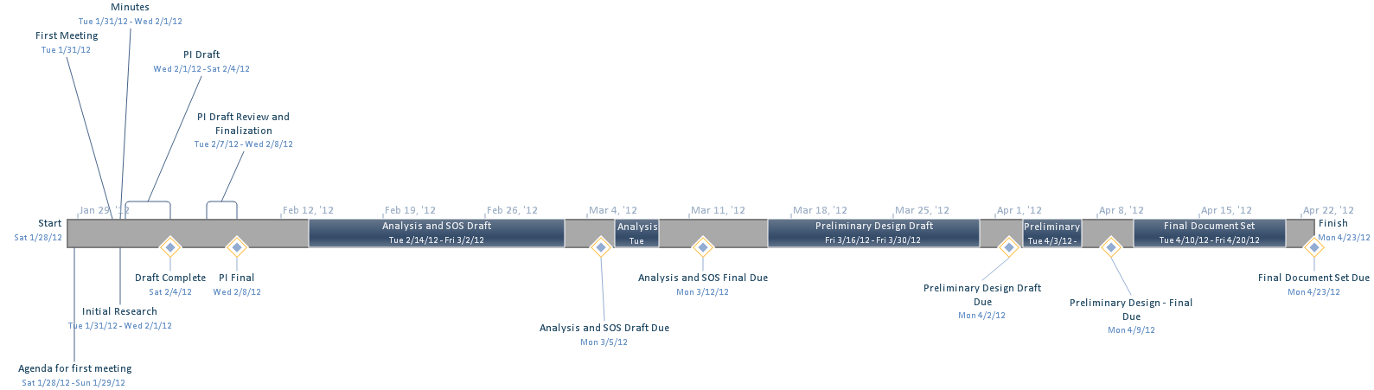

We are planning to finish the first draft of the preliminary investigation on Monday, February 6th, 2012 and its final draft finished by Monday, February 13th and delivered to the client. During this period of time we will be meeting a couple of milestones, the first milestone is the formation of the team, and our second one is finalizing the preliminary investigation. Along the way we will be having a meeting with the client on Tuesday, January 31th, 2012, and delivering the minutes by the end of the day. We are also planning on completing the first draft of the Analysis and Software Requirements by Monday, March 3rd, 2012, delivering a final version on Monday, March 12th 2012. The Preliminary Design draft will be completed on Monday, April 4th 2012, and the final version should be done by Monday, April 9th, 2012. The final documents will be due on Monday, April 23rd 2012.

# Team Operations

The team will follow the underlining rules and obligations in order to accomplish the goals:

* The team will have equal distribution of time and effort made for their perspective tasks with the rest of the team.
* The team will communicate via, Gmail, Google Docs, Cellphone and Face to Face Meetings.
* The team will meet regularly Monday Afternoon between 1pm and 4 pm. The team will also communicate via online means Tuesdays and Thursdays at 7:00 pm for 30 minutes. Attendance is not mandatory; emails will be dispensed to all after meeting of Minutes taken.
* The team will use a democratic voting system to determine decision making, and to help resolve conflict, we will initiate compromise.
* During meeting cell phone calls and text messages will be ignore, unless urgent.
* The team will request Faculty intervention when the team reaches a deadlock and have no other direction to take in working to a resolution.
* Member evaluation sheets for the Project lead will be administered at the end of assignment.
* Gmail will be used to distribute information to clients and team members.
* This agreement will support the Project Leaders authority to guide and direct this team to success.
* During each meeting, two members will take minutes to document all discussion and points made.
* The team will lightly confront members whose work is not up to group standards. Second offences will be of a more serious nature. Third, Faculty will be notified.

# Special Issues

We assume that the client will provide login information to access the website, as well as all source code for this project and any log in information for databases.

## 9.1 Outstanding Issues

No outstanding Issues.

# Commitment to the Charter

The Alpha Development Team created this charter and agrees to adhere to and be accountable for following its spirit and content. Agreement is shown through signing below.

______________________ _______________________ ___________

Team Leader’s name Team Leader’s signature Date

______________________ _______________________ ___________

Team Member’s name Team Member’s signature Date

______________________ _______________________ ___________

Team Member’s name Team Member’s signature Date

______________________ _______________________ ___________

Team Member’s name Team Member’s signature Date

______________________ _______________________ ___________

Team Member’s name Team Member’s signature Date

______________________ _______________________ ___________

Team Member’s name Team Member’s signature Date

## 10.1 Charter Approval Page

The charter has been reviewed and approved by:

______________________ _______________________ ___________

Project Professor’s name Project Professor’s signature Date